# MEETING MINUTES: SUMO DIGITAL GROUP PROJECT

**Date of Meeting : 20th March 2019**

**Time of Meeting : 11.25am – 11.55am**

Attendees:- Fraser King, Mircea Lazar, Mihai Giurea

Apologies from:- Harry Wadman, Sion Williamson

## Item One - Post-mortem of Previous Week

To summate, the sprint 7 objective overall was missed. In the previous week’s meeting minutes, a primary objective of achieving a “playtestable” product was outlined. Unfortunately, due to circumstances outside of the direct control of the group, this target was missed. As outlined in the sprint 7 communications screenshots available on the group’s GitHub repository (specifically “Sprint7_05.png”), Harry was hospitalised and subsequently unable to undertake his remote tasks. Due to the status of Harry’s tasks as blockers to this objective, this has resulted in a reshuffling of priorities for the next sprint and this will be fully discussed and itemized as part of item four below.

## Item Two – Tasks for the Current Sprint

The task breakdown for Sprint 8 is as follows:

|  |  |  |
| --- | --- | --- |
| **Team Member** | **Task Title(s)** | **Est.Time** |
| Fraser King | **\*Tasks to be Updated When Sprint is Live\*** |  |
| Mircea Lazar | **\*Tasks to be Updated When Sprint is Live\*** |  |
| Harry Wadman | **\*Tasks to be Updated When Sprint is Live\*** |  |
| Mihai Giurea | **\*Tasks to be Updated When Sprint is Live\*** |  |
| Sion Williamson | **\*Tasks to be Updated When Sprint is Live\*** |  |

## Item Three – Analysis and Review of Feedback

At the start of the 20/03 jam, Rob conducted a session with project managers highlighting the disparity between allotted hours (a minimum of 5 hours per member, per week) and completed, logged JIRA tasks. As the project was 7 complete weeks in at the time of this meeting, each team member should have approximately 35 hours worth of work logged inside of JIRA. The screenshot below shows the JIRA statistics for Group 16 (as of 1pm 20/03/19).

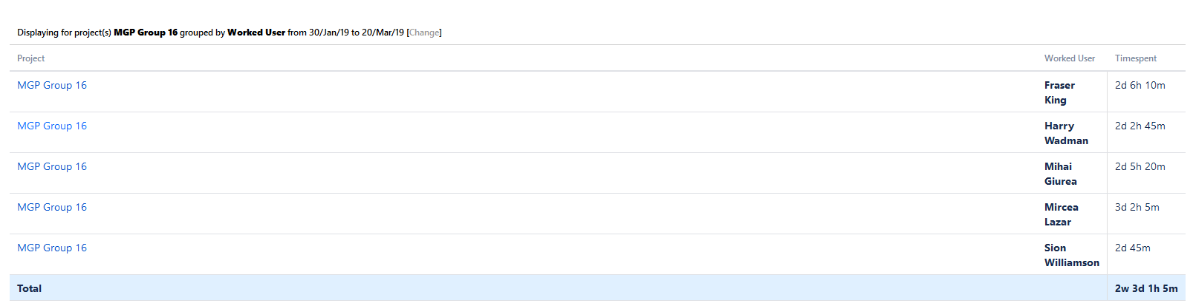

As, by default, JIRA tracks a singular day as an 8-hour ‘shift’, the converted details for each team member are visible in the table below.

|  |  |
| --- | --- |
| **Team Member** | **Time Logged in JIRA (as of 1pm 20/03/19)** |
| Fraser King | 22h 10m |
| Harry Wadman | 18h 55m |
| Mihai Giurea | 21h 20m |
| Mircea Lazar | 26h 5m |
| Sion Williamson | 16h 45m |
| ***Average Group Member*** | 21h 3m |

With time now logged against a more comparable formatting style, it is immediately clear that – on paper – Group 16 has a dramatically lower amount of time logged on JIRA in comparison to the expected minimum amount of 35 hours. With a total group average of 21 hours and 3 minutes logged in JIRA, on paper the group is only working at approximately 60% of minimum capacity – ***why is this?*** There are two primary reasons for this, in addition to a smaller, tertiary reason.

Firstly, since the initial week of the group project, no ‘administrative’ hours have been logged inside of JIRA (e.g. time spent in group meetings, setting up sprints, writing meeting minutes and logging Discord chats). After early consultation with third years and other groups, the team’s managers were under the impression that only tasks **directly related to the development of the game** were to be logged directly inside of JIRA(e.g. “Create a jumping script for the player character”). This alone has resulted in 5+ hours of unlogged work per individual member, in meetings alone.

Secondly, an additional factor for consideration is the time spent inside of scheduled Group Project module lectures – for example between the first introductory presentation and mid-project group presentations, 6 hours of unlogged group project time took place.

Lastly, a smaller consideration for the disparity in time logged in JIRA is that of the difference between task time logged vs task time allocated. Whilst as project managers, Mishu and I endeavour to provide accurate estimations of how long a task will take to complete, there is inevitably room for error, as either deadlines are missed as not enough time has been allocated or vice-versa with a task not taking the full amount of allotted time. Despite estimations getting more accurate over time as Mishu and I learn the capacity of each individual team member, these estimations can never be 100% accurate and collectively numerous hours of potential development have been lost consequentially.

Moreover, in light of this feedback, please find updated estimates of individual group member contribution summated in the table below (a full, detailed breakdown has been provided in an excel spreadsheet located under the ‘Admin’ folder of the group’s repository, titled “Group 16 Updated Hours”).

|  |  |  |
| --- | --- | --- |
| **Team Member** | **Time Logged in JIRA (as of 1pm 20/03/19)** | **Updated Total Time Spent (as of 1pm 20/03/19)** |
| Fraser King | 22h 10m | 42h 20m |
| Harry Wadman | 18h 55m | 29h 45m |
| Mihai Giurea | 21h 20m | 32h 15m |
| Mircea Lazar | 26h 5m | 46h 10m |
| Sion Williamson | 16h 45m | 27h |
| ***Average Group Member*** | 21h 3m | 35h 34m |

Furthermore, please also note that the updated total time spent values are inclusive of member absences – for example in two of the early sprints, Sion was absent from illness, thereby resulting in a total of 8h 30m worth of tasks (both in-jam and remotely) being missed – this, alongside other member absences, drags the mean ‘Total Time Spent’ average down considerably, however it is still above the minimum 35 hours. Again, please note that full data on team member absences is available in the aforementioned “Updated Hours” document.

Additionally, in response to this feedback, the group is now aggregating **all tasks** into the JIRA pipeline, thereby increasing the transparency of group tasks and mitigating this issue from occurring moving forwards. At the end of the group project, this estimated data will be recalculated with the JIRA sprint time data for sprints 8 – 12 to ensure that lecturers are presented with fair and accurate total time figures; these should also somewhat correlate with GitHub commits.

## Item Four – Objective of the Current Sprint

The objective for this sprint is twofold; first, the delivery of some form of ‘playtestable’ product is paramount by the end of this sprint – even if it is only suitable for gathering player character knockback feedback. This deliverable has been delayed for two consecutive weeks, and the group is collectively conscious to not repeat this delay again.

Next, the secondary objective for this sprint is clarification of the disparity between minutes logged in JIRA and actual time spent on the Group Project module. This point has been retrospectively reflected upon in Item Three of this document for clarity purposes.

**Meeting Ended :- 11.55am**

**Minute Taker:- Fraser King**